“Pâte à sel” recipe

What you need

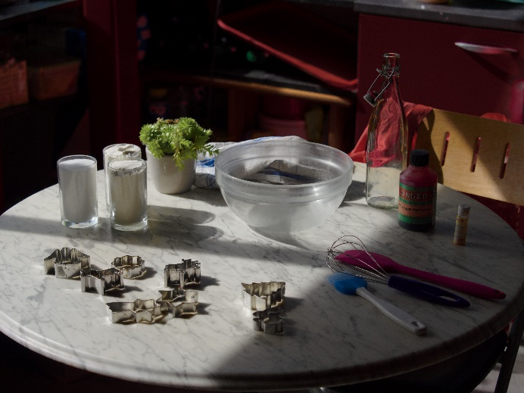
Ingredients
- 1 cup warm water
- 2 cups flour
- 1 cup salt
- Food coloring

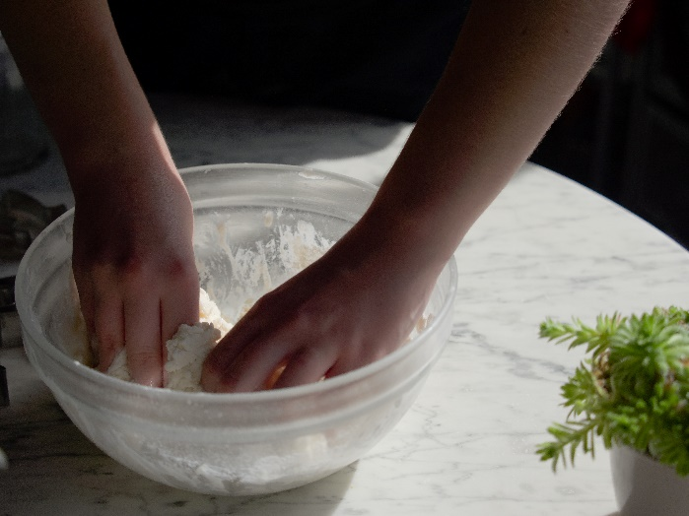
Utensils
- A bowl
- Cookie cutters

Recipe
Mix the salt and flour in the bowl, and add food coloring if necessary. Finally, add in warm water and work to a smooth workable paste. If it’s too friable, add in some more water. If it’s too sticky, add a little more flour.
Flatten the dough to approximately 1cm and cut whatever form you want into it. Once you’re done with your creation, put it in the oven at 75-110℃ for about an hour.
When you recreate the recipe at home, try to wrap the dough and let it rest for half a day to a day, so it doesn’t form bubbles when you cook it. You can also let the dough dry outside instead of cooking it. It may take more time but the result is the same.
You can also paint them afterwards instead of using food coloring.
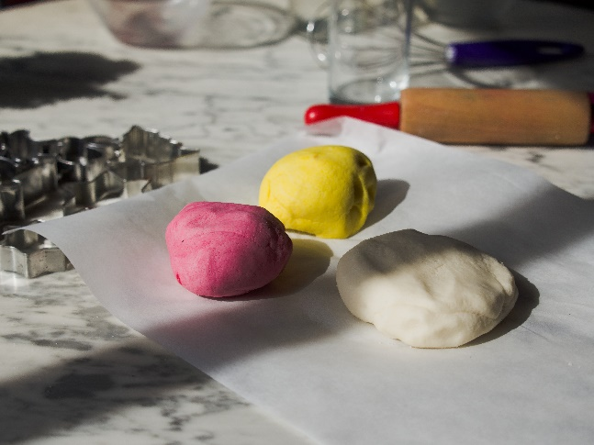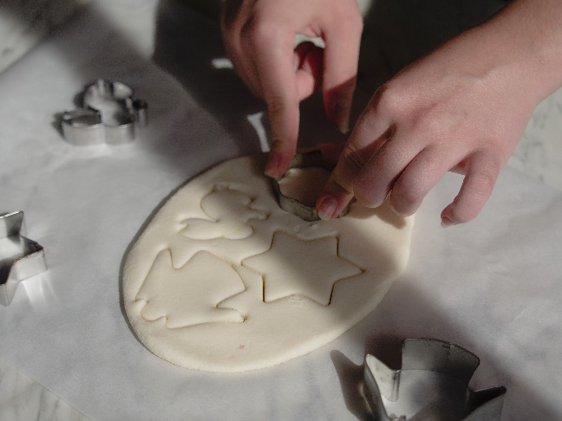

Useful vocabulary – 役に立つ単語
English | Katakana | Japanese
Ingredients | イングリーディエンツ | 材料（ざいりょう）
Water | ウオーター | 水（みず）
Salt | ソルト | 塩（しお）
Flour | フラワー | 小麦粉（こむぎこ）
To mix | トゥ・ミックス | 混ぜる（まぜる）
Dough | ドー | 生地（きじ）
To knead | トゥ・ニード | こねる
Cookie cutter | クッキー・カッター | 型抜き（かたぬき）
Christmas | クリスマス | クリスマス
Ornament | オーナメント | 飾り（かざり）

